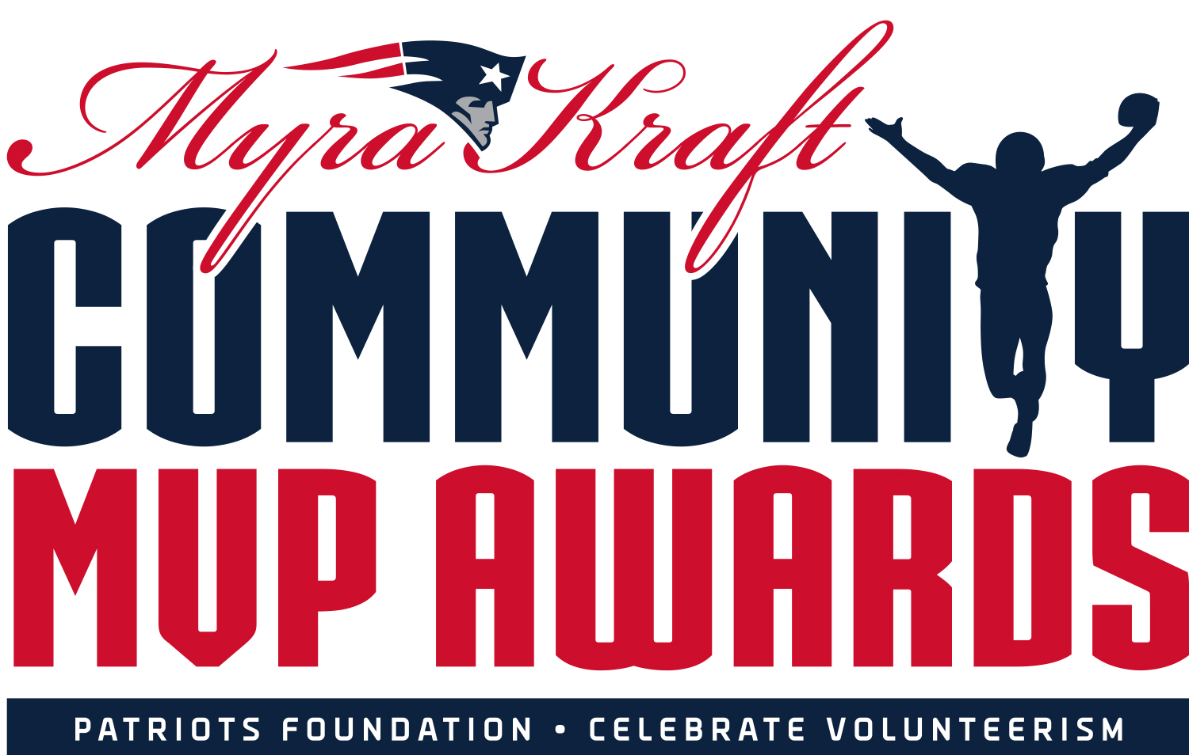
FOR IMMEDIATE RELEASE
Contact: Dan MacPherson; DMacPherson@kraftse.com; 774-226-3031

ROBERT KRAFT AND THE NEW ENGLAND PATRIOTS FOUNDATION DONATE $275,000 IN THE NAMES OF 2021 MYRA KRAFT COMMUNITY MVP AWARD WINNERS

Twenty-six nonprofits were recognized during an awards luncheon at Gillette Stadium on Wednesday, August 11

Bruce Connolly of Norwood, Mass. receives $10,000 for the Norwood Food Pantry

FOXBOROUGH, Mass. — Every year since 1998, the Kraft family and the New England Patriots have been celebrating those who give their time to help others. The program was originally known as the Community Quarterback Awards and were presented to those who exemplify leadership, dedication and a commitment to improving their communities through volunteerism.

In 2011, the awards were renamed in honor of the late Myra Kraft who committed her life to volunteering. As part of the New England Patriots Foundation’s ongoing Celebrate Volunteerism initiative, the Kraft family hosts a special luncheon each year to show their appreciation for local volunteers.

On Wednesday, Aug. 11, 26 volunteers were recognized for their contributions at an awards ceremony at Gillette Stadium. Twenty-five organizations received grants of $10,000 in honor of their outstanding volunteers and one grand prize winner received a surprise $25,000 donation.

On hand to congratulate the award winners were Patriots Chairman and CEO Robert Kraft, New England Patriots Foundation President Joshua Kraft and Patriots and Pro Football Hall of Famer and Patriots Executive Director of Community Affairs Andre Tippett.

“This marks the tenth year that this program has been named in memory of my sweetheart, Myra,” said Robert Kraft. “The past 18 months have been unlike anything we’ve experienced in our lifetime. During these challenging times, these 26 honorees stepped up to serve more children and families than ever before. We admire their selfless dedication and we know that Myra is smiling down on all of them.”

Bruce Connolly of Norwood, Mass. was recognized for his volunteer efforts and a $10,000 donation was presented to the Norwood Food Pantry.

Bruce was one of the food pantry’s first volunteers when they started serving six local families. Now – 32 years later – Bruce remains active with the nonprofit, helping to serve more than 350 families in need.

Known as the Energizer Bunny, Bruce has worn every hat for the organization, volunteering up to 7 days a week to serve families in need. As the supply and rotation manager, he makes sure that donations are being sorted, rotated and distributed.

“I’m honored to be the recipient of the Myra Kraft Community MVP Award,” said Bruce. “I accept it on behalf of the Ecumenical Community Food Pantry of Norwood, and of the many past and present volunteers, who through their houses of worship, or individually, have given of their time and energy, to assist the people of Norwood who are served by the food pantry.”

“I wish to remember Ruth Taeger, recently deceased, who was the former long-time executive director of the food pantry, and a person who set the standards for all Norwood Food Pantry volunteers,” Bruce continued. “In 2003, Ruth was selected to receive the ‘Community Quarterback Award,’ which was in the forerunner of this present-day award, and in 2004, she met both Robert and Myra Kraft as she received this prestigious award.”

Bruce also makes sure that leftover donations are distributed to other food sites and has been known to visit clients and volunteers who are sick. In addition to his efforts at the food pantry, Bruce volunteers as a lector, server and on various committees at his local church.

“We here at the Ecumenical Community Food Pantry of Norwood – also known as the Norwood Food Pantry – are very proud of Bruce for receiving this award,” said the nonprofit in a statement. “He’s been such a big part of our family here at the panty and rely on his wisdom and kindness as we all continue to support our community. Congratulations to Bruce, a most deserving volunteer.”

“Volunteering at the Norwood Food Pantry provides me with a means of manifesting my faith,” said Bruce. “And also, a means of strengthening the bond among the people of Norwood, which is the essence of community.

The 2021 Myra Kraft Community MVP winners range from 21 to 92 years old and represent every New England state. The selected nonprofits provide support for many causes, including education, domestic violence prevention, healthcare, homelessness, mentoring and military support.

The Kraft family and the New England Patriots Foundation received more than 250 applications this year from nonprofit organizations looking to recognize their outstanding volunteers. Nominations open each spring and the awards are open to all nonprofit organizations in the New England region. For more information on the Myra Kraft Community MVP Awards, please visit www.patriots.com/community.

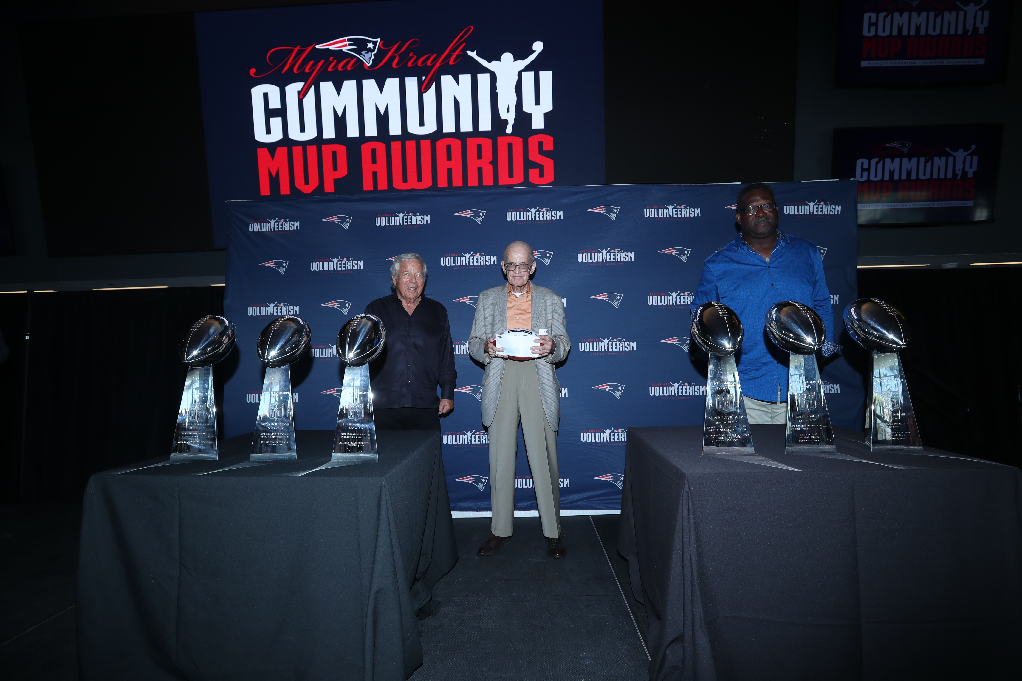
Patriots Chairman and CEO Robert Kraft and Patriots and Pro Football Hall of Famer Andre Tippett congratulate Bruce Connolly from the Norwood Food Pantry in Norwood, Mass. for being selected as a 2021 Myra Kraft Community MVP Award winner. During the August 11 luncheon, the Kraft family and the New England Patriots Foundation awarded $275,000 in grants to 26 New England nonprofits. The Norwood Food Pantry received a $10,000 grant in honor of Bruce’s volunteer efforts. (photo courtesy of Eric J. Adler/New England Patriots)

Below is a complete list of the 2021 Myra Kraft Community MVP Award Winners:

$25,000 Grand Prize Winner
First and Last Name Hometown Organization Organization Town
Phyllis Ellis Brockton, Mass. Family and Community Resources Brockton, Mass.

$10,000 Award Winners
First and Last Name Hometown Organization Organization Town
Lisa Allen Providence, R.I. Fall River Deaconess Home Fall River, Mass.
Jennifer Blum Fairhaven, Mass. The Help SAVE Foundation Fairhaven, Mass.
Eugene Brune Wilmington, Mass. Somerville Historical Society Somerville, Mass.
Phyllis Clawson Harvard, Mass. Virginia Thurston Healing Garden Harvard, Mass.
Bruce Connolly Norwood, Mass. Norwood Food Pantry Norwood, Mass.
Angela Cote Walpole, Mass. Prison Yoga Project Walpole, Mass.
Jacqueline Dewey Cape Neddick, Maine Dress a Girl Around the World Cape Neddick, Maine
Friday Night Hype Cambridge, Mass. Equity Roadmap, Inc. Cambridge, Mass.
Rebecca Gladstone Dover, Mass. A Place to Turn Natick, Mass.
Louise & Dave Hackett Merrimack, N.H. Gateways Community Services Nashua, N.H.
Alison Hornung N. Kingstown, R.I. Glimmer of Hope Foundation N. Kingstown, R.I.
Cyndi Jones Lexington, Mass. Wildflower Lexington, Mass.
Zayra Juarez Attleboro, Mass. The Literacy Center Attleboro, Mass.
Amy Katz Westport, Conn. Pink Aid Westport, Conn.
Bob Keiser Madison, Conn. APK Charities Corporation Madison, Conn.
Polly Kornblith Sherborn, Mass. Horse SenseAbility Sherborn, Mass.
Chris Kuhni Milbridge, Maine Women for Healthy Rural Living Milbridge, Maine
Raphael Landovitz Los Angeles, Calif. Camp Ta-Kum-Ta South Hero, Vt.
Joseph Mark Castleton, Vt. Castleton Community Seniors Castleton, Vt.
Ed Mastriano E. Providence, R.I. MENTOR Rhode Island Warwick, R.I.
Angela Matthews Rollinsford, N.H. The Black Heritage Trail of NH Portsmouth, N.H.
Marvia Murrell W. Bridgewater, Mass. The DJ Henry Dream Fund Boston, Mass.
Arielle Perry Northampton, Mass. Girls on the Run of Western Mass. Northampton, Mass.
Nancy Quintin N. Attleboro, Mass. Rock Steady Boxing N. Attleboro, Mass.
Deb & John Snow Foxborough, Mass. LYNN Ministries, Inc. Foxborough, Mass.

--PATRIOTS--

